475 BRANNAN
PRE CONSTRUCTION CHECK LIST
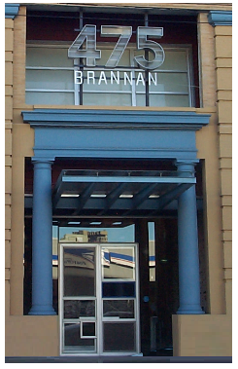
FLOOR _________ ZONES__________ TENANT______________________________

- PLACE CONSTRUCTION MATTING AT ENTRANCES

- SEAL ALL VENTILATION DUCT WORK

- SEAL ALL DOORS AND GAPS LEADING TO COMMON AREAS

- MAKE ALL MSDS AVAILABLE ON WORK SITE

- PROVIDE LIST OF CONTRACTORS

- PROVIDE WORK SCHEDULES

- PROVIDE PERMITS

475 BRANNAN
POST CONSTRUCTION CHECK LIST

FLOOR _________ ZONES__________ TENANT______________________________

- UPDATE EMERGENCY SHUTOFF AND EQUIPMENT FLOOR PLANS

- UPDATE FIRE ALARM POINTS MAPS

- UPDATE MONTHLY LIFE SAFETY INPECTION MAPS AND CHECKLIST

- UPDATE FIRE EXTINGUISHER MAPS AND CHECKLIST

- UPDATE KEYING SYSTEM LOGS

- UPDATE EMERGENCY PHONE CONTACTS

- ESTABLISH REQUIRED SERVICE MAINTENANCE CONTRACTS

- UPDATE ASBUILT DRAWING INDEX

- ESTABLISH FINAL PERMIT FOLDER

  - Include all special inspection reports and signoff

- GENERAL CONTRACTOR TO SUPPLY DIGITAL FORMAT OF ASBUILTS

475 BRANNAN
POST CONSTRUCTION CHECK LIST

FLOOR _________ ZONES__________ TENANT______________________________
- Architectural Drawings Hard/Digital Copy

- Mechanical Drawings Hard/Digital Copy

- Electrical Drawings Hard/Digital Copy

- Plumbing Drawings Hard/Digital Copy

- Fire Protection Drawings Hard/Digital Copy

- Fire Alarm Drawings Hard/Digital Copy

- Structural Drawings Hard Copy

- Misc. drawings Hard/Digital copy

- Provide final air/Water balance reports

- Provide signed approved submittal binder. Owner furnish equipment can be excluded.

- Provide O&M binders

  - Include paint index with manufacture color codes and finishes.
  - Include tile and carpet manufacture color codes and specs.

